CHAPTER SIX
RESULTS, ANALYSIS AND DISCUSSION
6.1 INTRODUCTION
This chapter presents the experimental results obtained from evaluating the proposed Federated Intrusion Detection System (FL-IDS) artefact using supervised machine learning techniques and publicly available intrusion detection datasets, The evaluation focused on measuring classification effectiveness, attack detection capability, and overall system performance using standard IDS evaluation metrics including accuracy, precision, recall, F1-score and confusion matrices.
The experiments were conducted using NSL-KDD intrusion detection dataset integrated into the artefact through a Random Forest classification engine. Visual analytics in the form of heatmaps, bar charts, and distribution graphs were generated to support interpretation of the results.
6.2 EXPERIMENTAL DATASET OVERVIEW
The evaluation utilized the NSL-KDD dataset, a widely recognized benchmark dataset for intrusion detection research. The dataset contains labelled network traffic records representing both normal and multiple categories of cyber attacks.
The dataset characteristics are summarized in Table 6.1
Table 6.1: NSL-KDD Dataset Characteristics
Attribute | Value
Total Records | 125 973
Features Used | 39
Classification Type | Multiclass
Number of Classes | 23
Machine Learning Algorithm | Random Forest

The attack categories evaluated included back, buffer_overflow,ftp_write,guess_passwd, imap, ipsweep, land, loadmodule, multihop, neptune, nmap, normal, perl, phf, pod, portsweep, rootkit, satan, smurf, spy, teardrop, warezclient, warezmaster.
Attack | Meaning | Category
back | HTTP-based DoS attack | DoS
buffer_overflow | Memory overflow exploit | U2R
ftp_write | Unauthorized ftp write | R2L
guess_passwd | Password guessing | R2L
imap | IMAP service explaoit | R2L
ipsweep | IP scanning | Probe
land | Spoofed SYN attack | DoS
loadmodule | Privilege escalation exploit | U2R
multihop | Multistage unauthorized access | R2L
neptune | TCP SYN flood | DoS
nmap | Port scanning | Probe
normal | Legitimate traffic | Normal
perl | Local privilege exploit | U2R
phf | CGI script exploit | R2L
pod | Ping of Death | DoS
portsweep | Port scanning | Probe
rootkit | Root-level malware | U2R
satan | Vulnerability probing/scanning | Probe
smurf | ICMP amplification DoS | DoS
spy | Network spying/sniffing | R2L
teardrop | Fragmentation DoS attack | DoS
warezclient | Illegal file transfer client activity | R2L
warezmaster | Illegal file distribution server | R2L
Table 6.2 Different attack categories and their meanings

KDD Cup (1999) KDD Cup 1999 Data. UCI KDD
Repository. Available at: http://kdd.ics.uci.edu/databases/kddcup99/kddcup99.html
Tavallaee, M., Bagheri, E., Lu, W. and Ghorbani, A.A. (2009) ‘A detailed analysis of the KDD CUP 99 data set’, in Proceedings of the 2009 IEEE Symposium on Computational Intelligence for Security and Defense Applications (CISDA 2009). Ottawa, Canada: IEEE, pp. 1–6.
The experimental evaluation utilized the NSL-KDD dataset, an improved version of the original cup 1999 intrusion detection benchmark dataset developed to address issues of redundancy and classifier bias (Tavallaee et al, 2009)
6.3 OVERALL IDS PERFORMANCE METRICS
The random Forest classifier demonstrated excellent classification performance during the evaluation.
Metric | Value
Accuracy | 99.86%
Precision | 99.84%
Recall | 99.86%
Weighted F1-score | 99.85%
Table 6.2 Overall IDS Performance
The results indicate that the proposed IDS framework achieved very high detection capability across the evaluated network traffic categories.

Overall IDS Performance Metrics
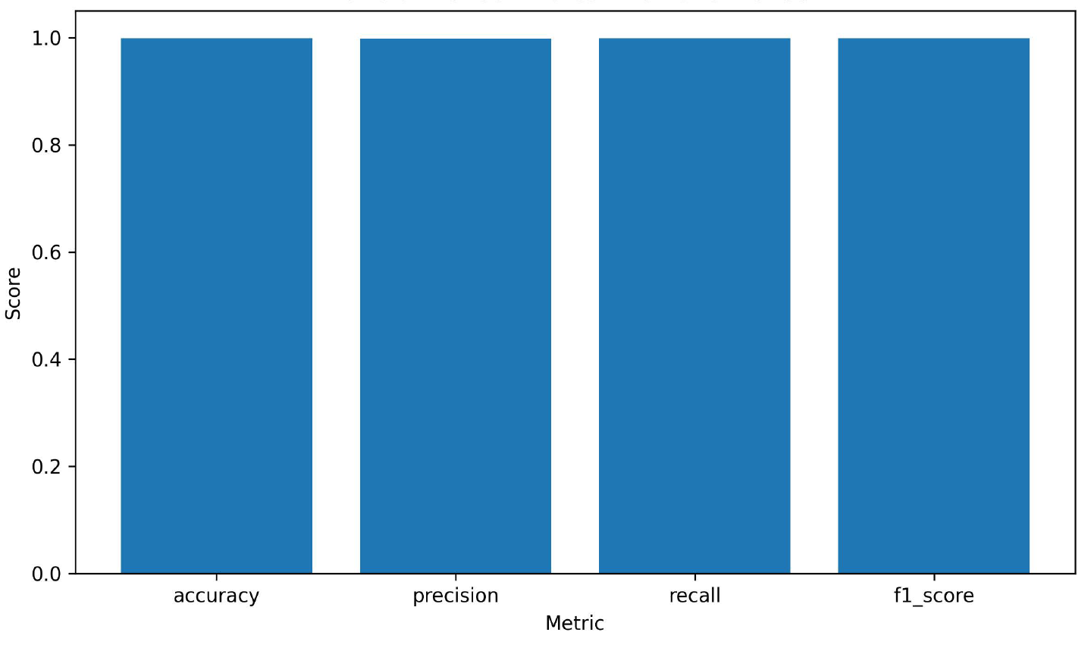
Figure 6. 1 Overall Metrics Bar

Figure 6.1 demonstrates that all major evaluation metrics achieved values close to 1.0, indicating a strong classification performance. The high weighted F1-score confirms that the system maintained a strong balance between precision and recall.
6.4 CONFUSION MATRIX ANALYSIS
The confusion matrix heatmap was generated to visualize the classification performance across all attack categories.

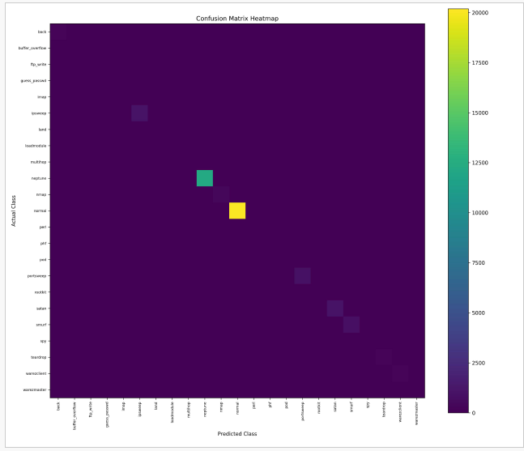
Figure 6. 2 Confusion Matrix Heatmap

The confusion matrix demonstrates that the majority of the attack classes were classified correctly with minimal misclassification. Dominant attack classes such as
- neptune,
- smurf,
- satan,
- ipsweep,
- portsweep
- and normal traffic achieved near perfect classification acc
However, certain minority classes such as
- ftp_write,
- loadmodule,
- multihop
- and spy experienced weaker detection performance due to limited training samples and severe class imbalance within the dataset.
6.5 ATTACK DISTRIBUTION ANALYSIS
The artefact generated attack category summaries to visualize the distribution of predicted attacks.
Predicted Attack Category Distribution
Figure 6. 3 Attack Distribution Bar
The results indicate that normal traffic and high-frequency attack categories such as Neptune and satan, constituted the majority of classified traffic. This indicates the imbalanced nature of the NSL-KDD dataset, where certain attacks occur far more frequently than others.
The system successfully identified multiple attack categories, demonstrating the capability of the framework to support multi-class intrusion detection rather than binary attack classification only.
6.6 PER- CLASS F1-SCORE EVALUATION
Per-class F1-scores were evaluated to determine the detection effectiveness for individual attack categories.
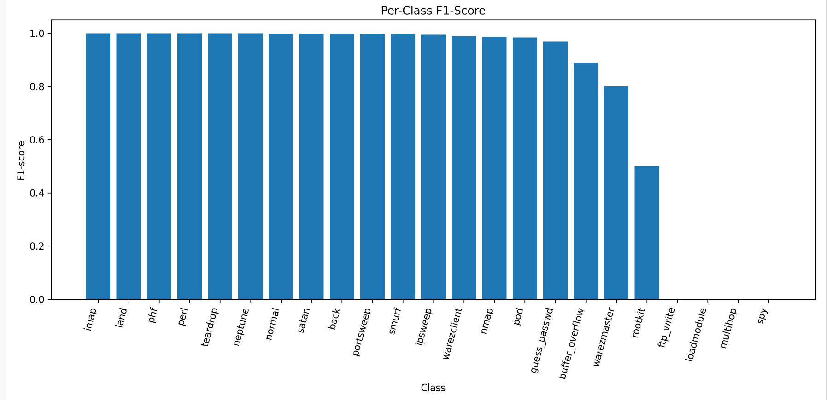
Figure 6. 4 Per-class F1-score Bar
The majority of dominant classes achieved F1-scores close to 1.0, indicating excellent detection capability. However, several low-frequency attack categories exhibited weaker performance.
This behavior is consistent with established intrusion detection research, where minority classes often suffer from insufficient representation during mode training.
Despite this limitation, the overall weighted F1-score remained extremely high, demonstrating strong generalized detection capability.

6.7 ACTUAL VERSUS PREDICTED TRAFFIC DISTRIBUTION
A comparison between actual and predicted traffic distributions was performed to evaluate classification consistency.
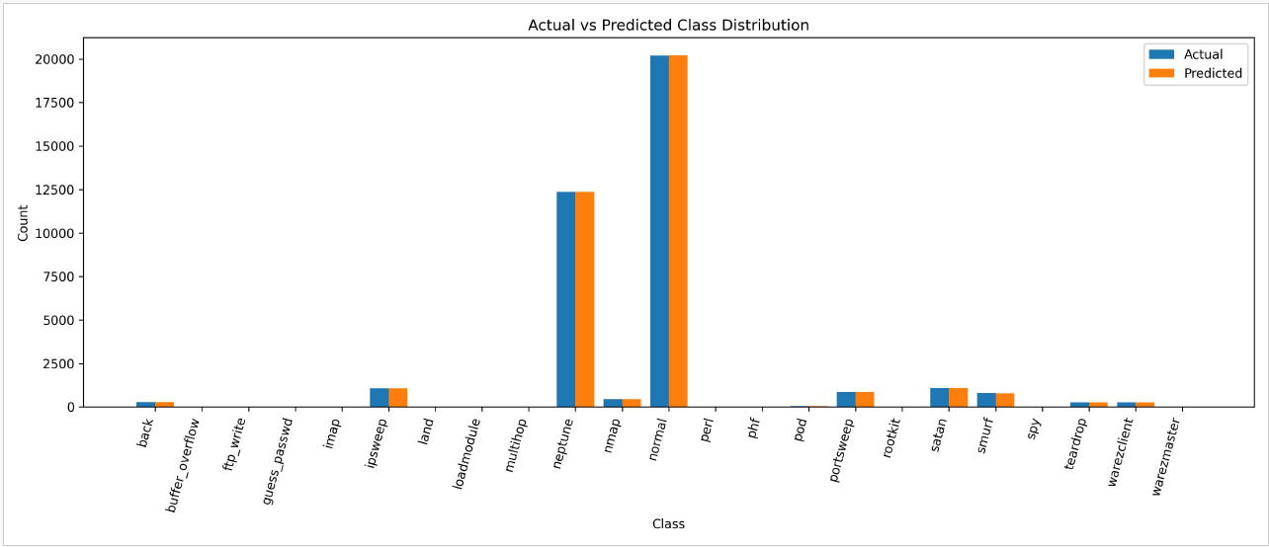
Figure 6. 5Actual vs Predicted Class Distribution
The predicted class distribution closely aligned with the actual traffic distribution , indication strong model generalization capability and low classification bias.
The results demonstrate that the Random Forest model maintained stable prediction performance across the majority of the evaluated attack categories.
6.8 DISCUSSION OF FINDINGS
The evaluation results demonstrate that the proposed IDS framework achieved strong intrusion detection performance using supervised machine learning integrated within the artefact architecture.
The key strengths observed include:
- a very high overall classification accuracy
- a strong weighted F1-score
- effective detection of dominant attack categories
- successful multi-class attack classification
- generation of interpretable visual analytics
However, several limitations were identified:
- minority attack classes suffered from limited detection capability
- dataset imbalance negatively affected rare attack prediction
- real-time deployment was not fully implemented
- federated aggregation was simulated rather than deployed across physically distributed IoT nodes.
Despite these limitations, the artefact successfully demonstrated the feasibility of integrating machine learning, intrusion detection evaluation, and visual analytics within a federated IDS framework.

